Design Twitter
Problem Statement: Create a simplified version of a social media platform similar to Twitter. Users should be able to post tweets, follow or unfollow other users, and view the 10 most recent tweets in their news feed.
Implement the Twitter class as follows:
- Twitter(): Initializes the Twitter object.
- void postTweet(int userId, int tweetId): Composes a new tweet with ID tweetId by the user userId. All tweetIds will be unique.
- List<Integer> getNewsFeed(int userId): Retrieves the 10 most recent tweet IDs in the user's news feed. The news feed should only show posts from users the user follows or from the user themself, with tweets arranged from most recent to least recent.
- void follow(int followerId, int followeeId): The user with ID followerId started following the user with ID followeeId. Input will be given such that followerId is not already following followeeId at the time of function call.
- void unfollow(int followerId, int followeeId): The user with ID followerId unfollowed the user with ID followeeId. Input will be given such that followerId is following followeeId at the time of function call.
Input: [postTweet(1, 2), postTweet(2, 6), getNewsFeed(1), follow(1, 2), getNewsFeed(1), unfollow(1, 2), postTweet(1,7), getNewsFeed(1)]
Output: [null, null, [2], null, [6, 2], null, [7, 2]]
Explanation:postTweet(1, 2): User with userId 1 posts tweet with tweetId 2. postTweet(2, 6): User with userId 2 posts tweet with tweetId 6. getNewsFeed(1): Outputs feed of userId 1 = [2]. follow(1, 2): User with userId 1 follows user with userId 2. getNewsFeed(1): Outputs feed of userId 1 = [6, 2], it contains the news of userId 2 as well. unfollow(1, 2): User with userId 1 unfollows user with userId 2. postTweet(1,7): User with userId 1 posts tweet with tweetId 7. getNewsFeed(1): Outputs feed of userId 1 = [7, 2].
Algorithm
The main challenge in this problem is retrieving the 10 most recent tweets across all followed users in an efficient way. Since each user may have multiple tweets, and tweets are ordered by recency, this becomes similar to merging K sorted lists (one per user). To do this optimally, we use a Max-Heap (priority queue) to always fetch the most recent tweet. The heap keeps at most one tweet from each list (user), and we simulate a merge sort–like process where we pop the latest tweet and push the next most recent tweet from the same user (if any). This ensures that we only process what's necessary instead of sorting everything or traversing all tweets.
- Maintain a map from each user to a list of their tweets (each tweet stores its timestamp).
- Maintain a map of user to set of users they follow.
- In postTweet(), add the tweet with a timestamp to the user’s list.
- In follow() and unfollow(), update the user's follow set accordingly.
- In getNewsFeed(), use a max heap to store the most recent tweets across all followed users and self.
- For each user being followed (including self), if they have tweets, push their most recent tweet into the heap along with an index pointer.
- Pop from the heap at most 10 times, each time adding that tweet ID to the result.
- If more tweets exist for that user, push the next recent tweet from their list into the heap.
- This simulates merging sorted tweet streams efficiently.
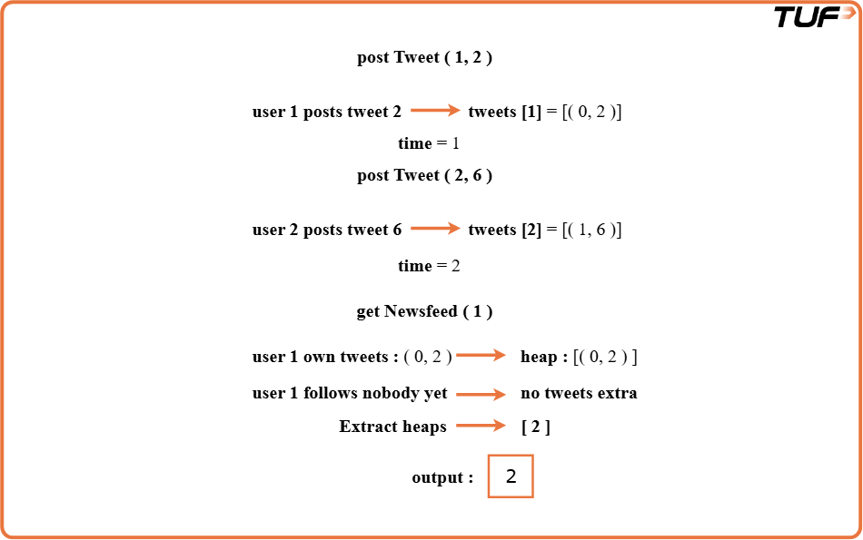
class Solution {
// Map to store user's tweets (timestamp, tweetId)
Map<Integer, List<int[]>> tweets;
// Map to store who follows whom
Map<Integer, Set<Integer>> following;
// Time counter to give each tweet a unique timestamp
int time;

// Constructor to initialize the system
public Solution() {
tweets = new HashMap<>();
following = new HashMap<>();
time = 0;
}

// Function to post a new tweet
public void postTweet(int userId, int tweetId) {
tweets.putIfAbsent(userId, new ArrayList<>());
tweets.get(userId).add(new int[]{time++, tweetId});
}

// Function to retrieve 10 most recent tweet IDs in the news feed
public List<Integer> getNewsFeed(int userId) {
PriorityQueue<int[]> pq = new PriorityQueue<>((a, b) -> a[0] - b[0]);

// Add own tweets
if (tweets.containsKey(userId)) {
for (int[] tweet : tweets.get(userId)) {
pq.offer(tweet);
if (pq.size() > 10)
pq.poll();
}
}

// Add tweets from followed users
if (following.containsKey(userId)) {
for (int followee : following.get(userId)) {
if (tweets.containsKey(followee)) {
for (int[] tweet : tweets.get(followee)) {
pq.offer(tweet);
if (pq.size() > 10)
pq.poll();
}
}
}
}

// Retrieve tweets in reverse order
LinkedList<Integer> res = new LinkedList<>();
while (!pq.isEmpty()) {
res.addFirst(pq.poll()[1]);
}
return res;
}

// Function to follow another user
public void follow(int followerId, int followeeId) {
following.putIfAbsent(followerId, new HashSet<>());
following.get(followerId).add(followeeId);
}

// Function to unfollow another user
public void unfollow(int followerId, int followeeId) {
if (following.containsKey(followerId))
following.get(followerId).remove(followeeId);
}
}

